Preparing an image for the Digital billboard Exhibition:

1. Open a COPY of the image in Photoshop
2. Select the crop tool on the left
3. Choose “ratio” from the pull down menu (upper left)
4. Type in the pixel dimensions you want (1400 x 400)
(This creates a crop box that will maintain the aspect ratio)

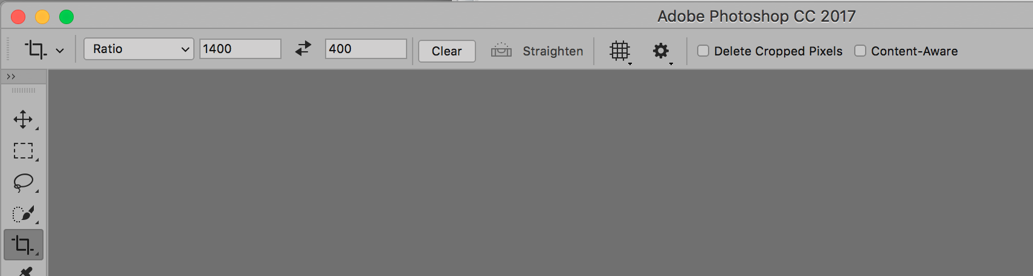

5. Move the crop box to the desired position; pull the corner of the crop box to resize and/ or rotate

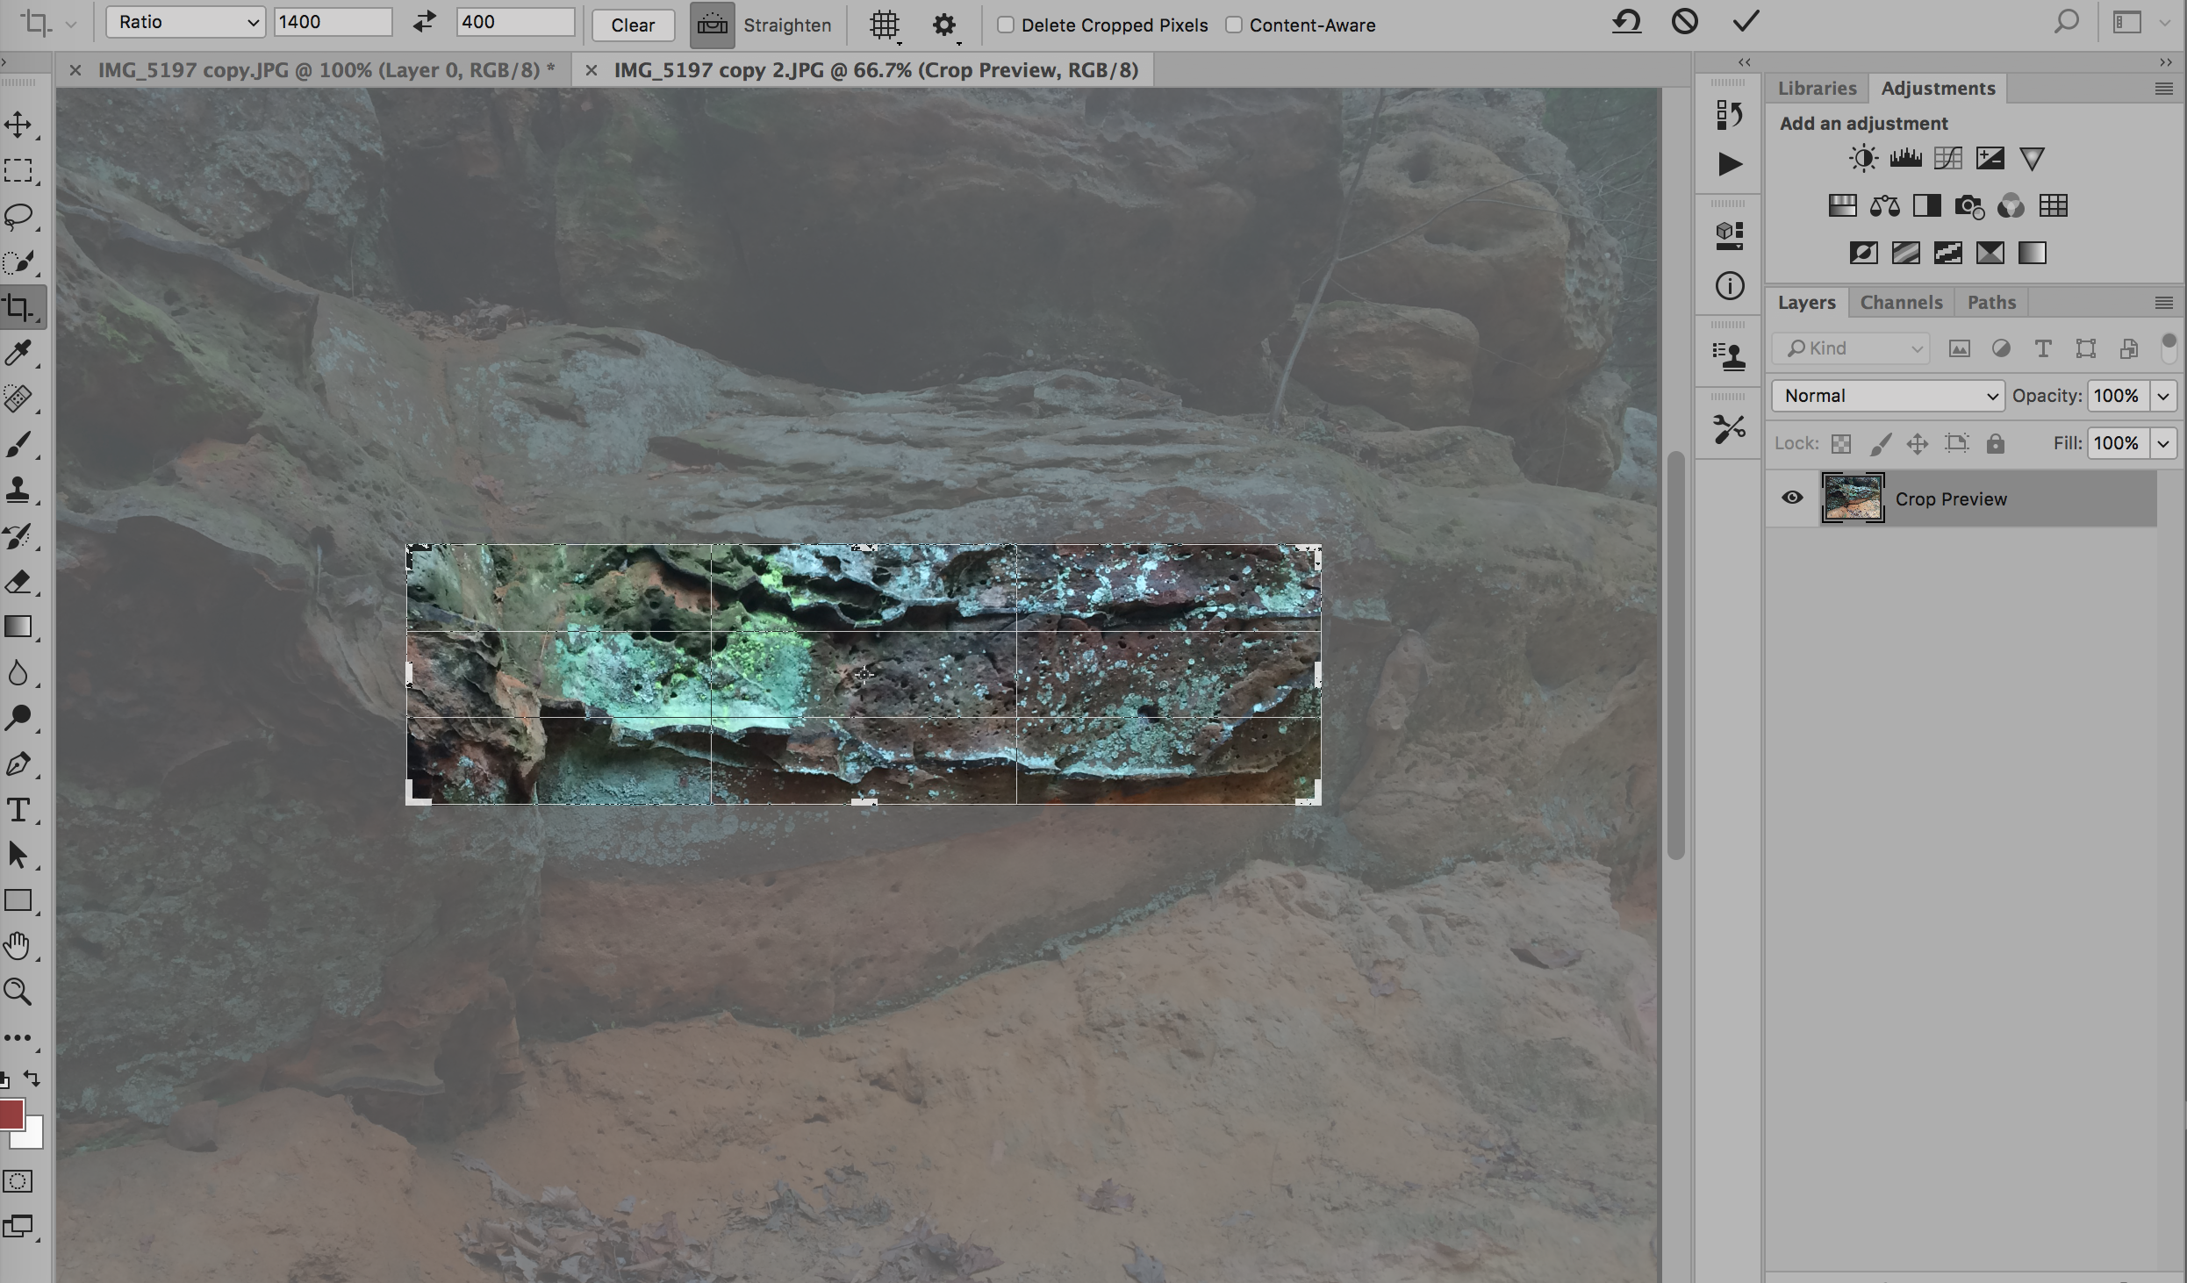

6. Tap “return” to apply the crop
7. Choose Image size (from the image pull down menu) and resize the actual pixel dimensions
to 1400 x 400 @ 72ppi (check resample image and choose pixels)

